CULTURAL COMPETENCY PLAN
ARIZONA OHANA SERVICES LLC

Effective Date: 12/2019
CEO/OWNER: ANGELA HARPER

I. INTRODUCTION
a. AOS has developed a Cultural Competency Program (CCP) to ͞support the creation of a culturally competent system of care that embraces and supports individual differences to achieve the best possible outcomes for individuals receiving services Culturally competency cultural considerations that include, but are not limited to the following:
Race Age Gender Identity Ethnicity Geographic Location Sexual Orientation Primary Language English Proficiency Family Roles Physical Abilities/Limitations Spiritual Beliefs and Practices Economic Status Literacy Community Networks Diverse Populations
AOS encourage participation in culture in the community!

MISSION
WE MAKE THE DIFFERENCE!
In everything we say and do, our goal is to “make the difference” in people’s lives, a positive difference! ‘The’ difference is a step above ‘a’ difference. It is going the ‘extra mile’ to make sure that you make a very positive impact on people’s lives. Our mission defines the “why” of “Why are we here?” to Make the Difference; a very positive difference in people’s lives!

Value:
We Value P.E.O.P.L.E.
People: see People as a “whole person”, first.
Environment: build an Environment of H.O.P.E., trust, and healthy relationships.

Opportunities: create Opportunities for growth and making G.O.O.D. decisions.
Provide: Provide gentle interactions to show you C.A.R.E.
Learn: Learn to appreciate differences in a team and treat all people with dignity and respect.
Empower: Empower by using S.O.U.L. and positive, open communication.

Member Demographic Considerations
The Division tracks member ethnicity, as reflected in the following charts, and uses the information to guide the CCP. Francine Waiters is the Cultural Competency Coordinator and is responsible for gathering and aggregating the data on a quarterly basis and overseeing the development of the CCP.
The Division’s membership breaks down as follows:
- White Non-Hispanic (52%)
- Hispanic or Latino (31%)
- American Indian/Alaska Native (5%)
- Black or African American (Non-Hispanic) (6.5%)
- Other/Unknown (3%)
- Asian/Pacific Islander (2%)
With 31% of the Division’s membership identifying as Hispanic/Latino, the AOS is committed to the continued need for a culturally competent workforce that matches the racial and ethnicity of its members.

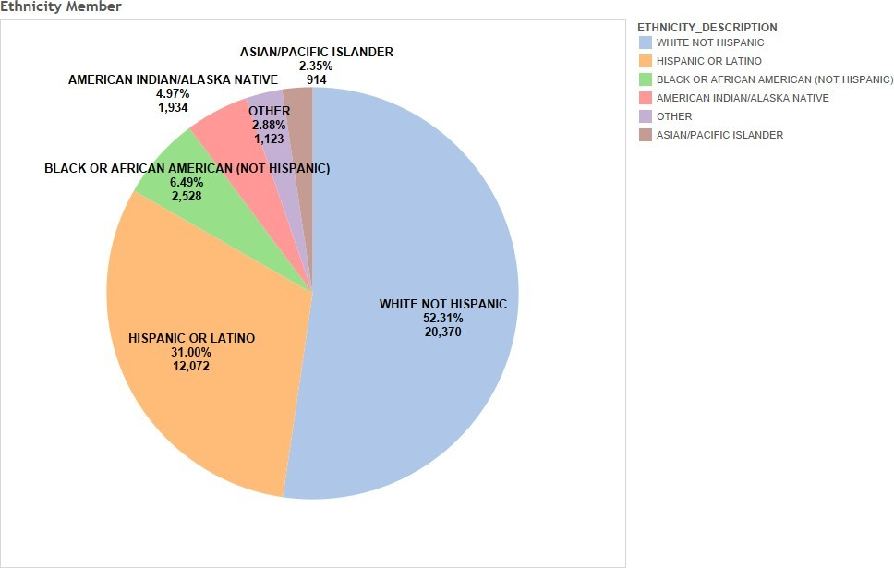

Population Assessment-
United States Census Bureau quick facts are in Appendix A. An important element in developing and maintaining culturally aware services is to understand the demographic composition of the individuals the organization serves.
Link to United States Census Bureau quick facts: https://www.census.gov/quickfacts/fact/table/calhouncountymichigan,vanburencountymichigan,berriencountymichigan,casscountymichigan/LFE046217 http://www.census.gov/quickfacts/table/LFE046215/26025,2609950480,26125,26159,26021,26027

Goals
“Cultural competency” refers to AOS staff:
- Acknowledge, understand, respect and apply the influence of the following when assessing, treating, and interacting with any individual and/or families:
  - Cultural history
  - Life experiences
  - Language differences
  - Values
  - Customs
  - Cultural differences among diverse racial, ethnic, and other minority groups
  - Customs ▪ Beliefs.
- Ensure use of “disability etiquette” when establishing rapport and working with individuals with developmental disabilities. Disability etiquette is a set of guidelines dealing specifically with how to approach people with disabilities.
- Ensure communication of progress in implementing and sustaining the goals of the CCP to stakeholders, members, and the public.

Ensure that staffing supports are provided in a culturally competent manner to all people, including those with limited English proficiency, through the training provided at the time of hire and ongoing, evaluations of compliance grievance/complaints, and person supported satisfaction survey result on cultural competency.

- AOS staff will effectively provide supports to all people regardless of their ages, cultures, races, ethnicities, gender identification, gender expression, and religions. • Review the demographic profiles of the service areas (Refer to Population Assessment; Census data for AOS support locations in Appendix A.
- Appendix A. Population Assessment- United States Census Bureau quick facts An important element in developing and maintaining culturally aware services is to understand the demographic composition of both the population of the individuals the organization serves, but also the demographic composition of the population in the catchment area(s) of the organization. Link to United States Census Bureau quick facts:

https://www.census.gov/quickfacts/fact/table/calhouncountymichigan,vanburencountymichigan,berriencountymichigan,casscountymichigan/LFE046217 http://www.census.gov/quickfacts/table/LFE046215/26025,2609950480,26125,26159,26021,26027

Agency background and services provided
We are contracted and funded by az Division of Developmental Disabilities. Our agency provides home- based services to adult and children with disabilities. promotes a culture of respect when working with members and their families. AOS values a competent and diverse workforce capable of effectively addressing the needs and preferences of members with diverse cultures and languages.

Training
All Employee Training
AOS incorporates philosophical and historical information regarding the disability community, behaviors, attitudes, skills, policies and procedures in its staff development program. Developing cultural competence in the area of developmental disabilities is a primary focus of these trainings.
The Division issues to its provider and all AOS staff follows standardized training materials such as Managing Inappropriate Behaviors, Positive Behavioral Support, and the AHCCCS Direct Care Worker modules. One purpose of this training is to develop cultural competency in working with individuals with developmental disabilities.
AOS staff will be train on the Division Culture Competency Plan

Communication/ Recruitment of staff
AOS will use for language/ document translation
- Onsite Bilingual staff
- All document be available in English and Spanish.
- Provide Spanish training classes
- Will match staff with members/ family language preference

